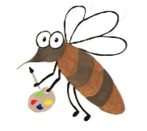

Lyng Primary School Knowledge Organiser

Art

How can the position of colour impact a piece of art?

Year 5

Topic: Art

Summer

|  |  |
| --- | --- |
| Vocabulary | |
| **Spelling** | **definition** |
| Mosaics | A picture of pattern produced by arranging together small pieces of stone, glass or tile |
| Tile | tile is a thin object usually square or rectangular in shape. Tile is a hard-wearing material such as ceramic, stone, metal, baked clay, or even glass, generally used for covering roofs, floors, walls. |
| Geometric | A pattern or arrangement made up of shapes such as squares, triangles or rectangles. |
| Depicted | Represent by a drawing, painting, or other art form. |
| Tessarae | A small block of stone, tile, glass, or other material used in the construction of a mosaic. |

Background information for parents and teachers

Mosaics were used in a variety of private and public buildings, on both floors and walls. They were highly influenced by earlier and contemporary Hellenistic Greek mosaics, and often included famous figures from history and mythology. The most notable mosaics that are still in tact can be found on walls of buildings and on floors of villas in Italy.

Children will explore the works of:

**Summer term**

Roman mosaic

|  |
| --- |
| Skills and techniques |
| Use ceramic mosaic materials and techniques.  Show life-like qualities and real-life proportions or, if more abstract, provoke different interpretations.  Use frameworks (such as wire or moulds) to provide stability and form. Show how the work of those studied was  influential in both society and to other artists.  Create original pieces that show a range of influences and styles. |

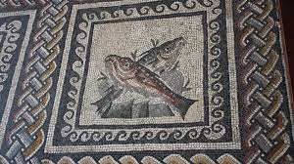

Mosaic

A mosaic is a pattern or image made of small regular or irregular pieces of coloured stone, glass or ceramic, held in place by plaster/mortar, and covering a surface. Mosaics are often used as floor and wall decoration, and were particularly popular in the Ancient Roman world. It is a captivating technique that involves decorating a surface with intricate designs made from closely arranged usually multi-coloured pieces of material such as tone, mineral, glass, tile or shell.

Agreed outcome:

Roman mosaic – patterns seen in real life

Roman mosaics. Linked to maths.